**The Ideas Place Round 1 Case Study (Kyle Quinn)**

1. **Your Name?**

Kyle Quinn

1. **Business Name?**

Gourmet Fungi Co.

1. **City?**

Warrnambool, Victoria, 3280

1. **Business Website?**

**https://www.gourmetfungico.com.au/**

1. **Can you briefly describe your business/product idea?**

Step into the world of Gourmet Fungi Co., where the art of cultivating naturally grown gourmet mushrooms intertwines with a passion for ethical food choices and culinary innovation. From fresh, vibrant mushrooms to captivating DIY Home Grow Kits, our journey transcends plates – it's a community-driven symphony where flavors mingle, and creativity thrives.

1. **Can you describe how participating in The Ideas Place Ignite/Bootcamp Programs helped you with your business/product idea?**

The Ideas Place Ignite and Bootcamp Programs have been pivotal for the growth of Gourmet Fungi Co., providing crucial insights and resources. These programs went beyond workshops, connecting us with experts and like-minded individuals. Guided by their insights, we navigated with newfound confidence, weaving camaraderie that underscored shared growth. Structured guidance fueled our business journey, turning dreams into milestones. The Ideas Place is more than an event; it accelerates evolution, shaping us with expertise and collaboration. Thanks to their influence, Gourmet Fungi Co. has thrived as a testament to innovative support. Their mentorship and feedback guided our growth and sustainability initiatives, refining our business model, product offerings, and brand messaging.

1. **What would you say to other start-up/scale-up businesses considering getting involved in The Ignite Program/Bootcamps?**

To those venturing into the entrepreneurial landscape, consider embracing The Ignite Program/Bootcamps by The Ideas Place. These programs offer a space where guidance, collaboration, and practical tools converge. Imagine mentors who are not just guides, but companions on your journey, and an environment that nurtures growth. Seize this opportunity to thrive. The Ignite Program/Bootcamps serve as fertile ground for your vision. Knowledge transforms into actionable strategies, connections evolve into valuable partnerships, and your entrepreneurial spirit finds support. Embrace the journey—one step at a time, each contributing to meaningful progress. Let The Ignite Program/Bootcamps illuminate your path, unveiling opportunities to shape a narrative that's authentically yours, driven by creativity and purpose. Forge ahead and flourish!

1. **Please provide any other words of advice for others looking to start their business journey**

Dear Visionaries,

* + Congratulations on stepping into the entrepreneurial arena! Here's distilled wisdom for your journey:  
    **Persist & Rise:** Entrepreneurship is a marathon; tenacity is your ally. Setbacks shape strength.
  + **Embrace Learning:** Seek knowledge from successes and failures—it fuels growth.
  + **Adapt & Thrive:** Flexibility is your superpower in a shifting landscape.
  + **Forge Connections:** Network genuinely; mentors and peers uplift your path.
  + **Risk Fuels Innovation:** Calculated risks are your innovation catalyst.
  + **Impact over Perfection:** Solve problems, create impact—perfection can wait.
  + **Well-Being Matters:** Nourish your mind, body, and soul—it's your foundation.
  + **Celebrate Progress:** Small wins pave the path to grand victories.
  + **Embrace Feedback:** Feedback refines; approach it with humility.
  + 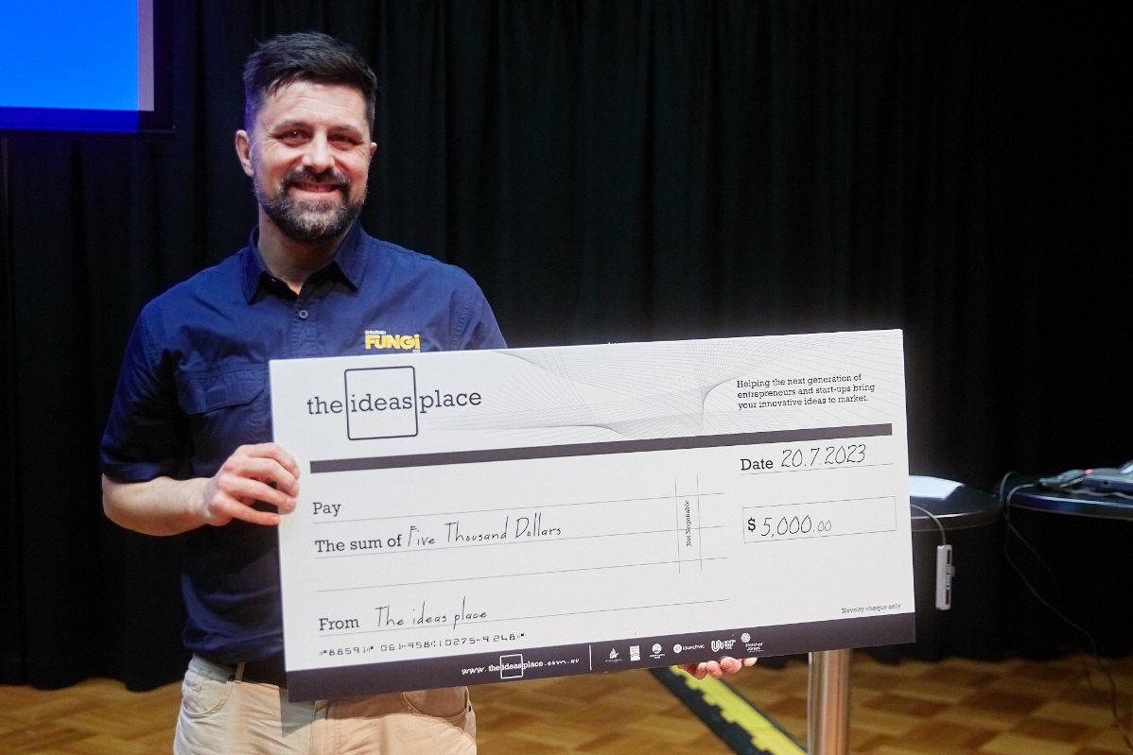**Authenticity Shines:** Infuse your unique essence into every endeavor.